CONTROLLING IP SPOOFING THROUGH INTER DOMAIN PACKET FILTERS

Abstract:
The Distributed Denial-of-Service (DDoS) attack is a serious threat to the legitimate use of the Internet. Prevention mechanisms are thwarted by the ability of attackers to forge or spoof the source addresses in IP packets. By employing IP spoofing, attackers can evade detection and put a substantial burden on the destination network for policing attack packets. In this paper, we propose an inter domain packet filter (IDPF) architecture that can mitigate the level of IP spoofing on the Internet. A key feature of our scheme is that it does not require global routing information. IDPFs are constructed from the information implicit in Border Gateway Protocol (BGP) route updates and are deployed in network border routers. We establish the conditions under which the IDPF framework correctly works in that it does not discard packets with valid source addresses. Based on extensive simulation studies, we show that, even with partial employment on the Internet, IDPFs can proactively limit the spoofing capability of attackers. In addition, they can help localize the origin of an attack packet to a small number of candidate networks.

Introduction:
Distributed Denial-of-Service (DDoS) attacks pose an increasingly grave threat to the Internet, as evident in recent DDoS attacks mounted on both popular Internet sites and the Internet infrastructure. Alarmingly, DDoS attacks are observed on a daily basis on most of the large backbone networks. One of the factors that complicate the mechanisms for policing such attacks is IP spoofing, which is the act of forging the source addresses in IP packets. By masquerading as a different host, an attacker can hide its true identity and location, rendering source based packet filtering less effective. It has been shown that a large part of the Internet is vulnerable to IP spoofing. Recently, attackers have increasingly been staging attacks via botnets. In this case, since the attacks are carried out through intermediaries, that is, the compromised “bots,” attackers may not utilize the technique of IP spoofing to hide their true identities. It is tempting to believe that the use of IP spoofing is less of a factor. However, recent studies show that IP spoofing is still a common phenomenon: it is used in many attacks, including the high-profile DDoS attacks on root DNS servers in early February 2006. In response to this event, the ICANN Security and Stability Advisory Committee made three recommendations. The first and long-term recommendation is to adopt source IP address verification, which confirms the importance of the IP spoofing problem. IP spoofing will remain popular for a number of reasons. First, IP spoofing makes isolating attack traffic from legitimate traffic harder: packets with spoofed source addresses may appear to be from all around the Internet. Second, it presents the attacker with an easy way to insert a level of indirection. As a consequence, substantial effort is required to localize the source of the attack traffic. Finally, many popular attacks such as man-in-the-middle attacks, reflector-based attacks, and TCP SYN flood attacks use IP spoofing and require the ability to forge source addresses.
Although attackers can insert arbitrary source addresses into IP packets, they cannot control the actual paths that the packets take to the destination. Based on this observation, Park and Lee proposed the route-based packet filters as a way of mitigating IP spoofing. The idea is that by assuming single-path routing, there is exactly one single path pðs; dÞ between the source node s and the destination node d. Hence, any packet with the source address s and the destination address d that appear in a router that is not in pðs; dÞ should be discarded. The challenge is that constructing such a routebased packet filter requires the knowledge of global routing information, which is hard to reconcile in the current Internet routing infrastructure.
SYSTEM STUDY

FEASIBILTY STUDY

The feasibility of the project is analyzed in this phase and business proposal is put forth with a very general plan for the project and some cost estimates. During system analysis the feasibility study of the proposed system is to be carried out. This is to ensure that the proposed system is not a burden to the company. For feasibility analysis, some understanding of the major requirements for the system is essential.
The feasibility study investigates the problem and the information needs of the stakeholders. It seeks to determine the resources required to provide an information systems solution, the cost and benefits of such a solution, and the feasibility of such a solution. The analyst conducting the study gathers information using a variety of methods, the most popular of which are:
- Interviewing users, employees, managers, and customers.
- Developing and administering questionnaires to interested stakeholders, such as potential users of the information system.
- Observing or monitoring users of the current system to determine their needs as well as their satisfaction and dissatisfaction with the current system.
- Collecting, examining, and analyzing documents, reports, layouts, procedures, manuals, and any other documentation relating to the operations of the current system.
- Modeling, observing, and simulating the work activities of the current system.
The goal of the feasibility study is to consider alternative information systems solutions, evaluate their feasibility, and propose the alternative most suitable to the organization. The feasibility of a proposed solution is evaluated in terms of its components. These components are:

- ECONOMICAL FEASIBILITY
- TECHNICAL FEASIBILITY
- SOCIAL FEASIBILITY
- OPERATIONAL FEASIBILITY

ECONOMICAL FEASIBILITY

This study is carried out to check the economic impact that the system will have on the organization. The amount of fund that the company can pour into the research and development of the system is limited. The expenditures must be justified. Thus the developed system as well within the budget and this was achieved because most of the technologies used are freely available. Only the customized products had to be purchased.

TECHNICAL FEASIBILITY

This study is carried out to check the technical feasibility, that is, the technical requirements of the system. Any system developed must not have a high demand on the available technical resources. This will lead to high demands on the available technical resources. This will lead to high demands being placed on the client. The developed system must have a modest requirement, as only minimal or null changes are required for implementing this system.

SOCIAL FEASIBILITY

The aspect of study is to check the level of acceptance of the system by the user. This includes the process of training the user to use the system efficiently. The user must not feel threatened by the system, instead must accept it as a necessity.

The level of acceptance by the users solely depends on the methods that are employed to educate the user about the system and to make him familiar with it. His level of confidence must be raised so that he is also able to make some constructive criticism, which is welcomed, as he is the final user of the system.

OPERATIONAL FEASIBILITY
The ability, desire, and willingness of the stakeholders to use, support, and operate the proposed computer information system. The stakeholders include management, employees, customers, and suppliers. The stakeholders are interested in systems that are easy to operate, make few, if any, errors, produce the desired information, and fall within the objectives of the organization.
System analysis:
Existing System:
Route-based Packet Filter:
Route-based distributed packet filtering (DPF) uses routing information to determine if a packet arriving at a router— e.g., border router at an AS—is valid with respect to its inscribed source/destination addresses, given the reach ability constraints imposed by routing and network topology. A single AS can only exert a limited impact with respect to identifying and discarding forged IPflows.
As with routing, route-based packet filtering occurs at two time scales—packet forwarding/discard based on table look-up (fast) and filter table update (slow)—and thus its forwarding/discard function can be performed close to line speed subject to generic processing overhead.

Disadvantages
- IP spoofing may easily occur. Because the packet-filtering router permits or denies a network connection based on the source and destination addresses of the packet, any attack that uses valid IP address may not be detected.
- Packet-filtering rules are comparatively harder to be designed and configured

Proposed System:
Inter domain Packet Filter:
Definition 1:(stable routing state). A routing system is in a stable state if all the nodes have selected a best route to reach other nodes and no route updates are generated (or propagated).
Definition 2: (route-based packet filtering). Node v accepts packet M(s,d) that is forwarded from node u if and only if e(u,v) belongs to R(s,d). Otherwise, the source address of the packet is spoofed, and the packet is discarded by v.
Definition 3: (correctness of packet filtering). A packet filter is correct if it does not discard packets with valid source addresses when the routing system is stable.
Advantages
- IDPFs can significantly limit the spoofing capability of an attacker.
- Moreover, they also help pinpoint the true origin of an attack packet to be within a small number of candidate networks, thus simplifying the reactive IP trace back process.

SYSTEM REQUIREMENTS

Hardware Interface:
Hard disk : 320 GB
RAM : 4GB
Processor : Intel i3

Software Interface:
JDK 1.5 or above
Swing Builder
SQL Server 2005

Software Description
Java:
Java was conceived by James Gosling, Patrick Naughton, Chris Wrath, Ed Frank, and
Mike Sheridan at Sun Micro system. It is an platform independent programming
language that extends it’s features wide over the network.Java2 version introduces an
new component called “Swing” – is a set of classes that provides more power
& flexible components than are possible with AWT.
- It’s a light weight package, as they are not implemented by platform-specific code.
-Related classes are contained in javax.swing and its sub packages, such as javax.swing.tree.
-Components explained in the Swing have more capabilities than those of AWT

What Is Java?
Java is two things: a programming language and a platform.
The Java Programming Language
Java is a high-level programming language that is all of the following:
- Simple
- Object-oriented
- Distributed
- Interpreted
- Robust
- Secure
- Architecture-neutral
- Portable
- High-performance
- Multithreaded
- Dynamic

Java is also unusual in that each Java program is both compiled and interpreted. With a compiler, you translate a Java program into an intermediate language called Java byte codes--the platform-independent codes interpreted by the Java interpreter. With an interpreter, each Java byte code instruction is parsed and run on the computer. Compilation happens just once; interpretation occurs each time the program is executed. This figure illustrates how this works.

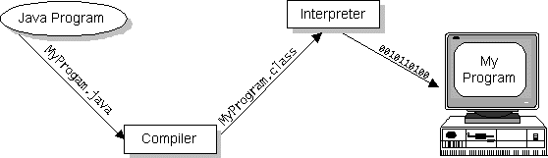

Java byte codes can be considered as the machine code instructions for the Java Virtual Machine (Java VM). Every Java interpreter, whether it's a Java development tool or a Web browser that can run Java applets, is an implementation of the Java VM. The Java VM can also be implemented in hardware.
Java byte codes help make "write once, run anywhere" possible. The Java program can be compiled into byte codes on any platform that has a Java compiler. The byte codes can then be run on any implementation of the Java VM. For example, the same Java program can run on Windows NT, Solaris, and Macintosh.

The Java Platform
A platform is the hardware or software environment in which a program runs. The Java platform differs from most other platforms in that it's a software-only platform that runs on top of other, hardware-based platforms. Most other platforms are described as a combination of hardware and operating system.

The Java platform has two components:
- The Java Virtual Machine (Java VM)
- The Java Application Programming Interface (Java API)
The Java API is a large collection of ready-made software components that provide many useful capabilities, such as graphical user interface (GUI) widgets. The Java API is grouped into libraries (packages) of related components.
The following figure depicts a Java program, such as an application or applet, that's running on the Java platform. As the figure shows, the Java API and Virtual Machine insulates the Java program from hardware dependencies.
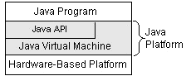

As a platform-independent environment, Java can be a bit slower than native code. However, smart compilers, well-tuned interpreters, and just-in-time byte code compilers can bring Java's performance close to that of native code without threatening portability.

What Can Java Do?
Probably the most well-known Java programs are Java applets. An applet is a Java program that adheres to certain conventions that allow it to run within a Java-enabled browser.
However, Java is not just for writing cute, entertaining applets for the World Wide Web ("Web"). Java is a general-purpose, high-level programming language and a powerful software platform. Using the generous Java API, we can write many types of programs.
The most common types of programs are probably applets and applications, where a Java application is a standalone program that runs directly on the Java platform.
How does the Java API support all of these kinds of programs?
With packages of software components that provide a wide range of functionality. The core API is the API included in every full implementation of the Java platform. The core API gives you the following features:
- The Essentials: Objects, strings, threads, numbers, input and output, data structures, system properties, date and time, and so on.
- Applets: The set of conventions used by Java applets.
- Networking: URLs, TCP and UDP sockets, and IP addresses.
- Internationalization: Help for writing programs that can be localized for users worldwide. Programs can automatically adapt to specific locales and be displayed in the appropriate language.
- Security: Both low-level and high-level, including electronic signatures, public/private key management, access control, and certificates.
- Software components: Known as JavaBeans, can plug into existing component architectures such as Microsoft's OLE/COM/Active-X architecture, OpenDoc, and Netscape's Live Connect.
- Object serialization: Allows lightweight persistence and communication via Remote Method Invocation (RMI).
- Java Database Connectivity (JDBC): Provides uniform access to a wide range of relational databases.
- Java not only has a core API, but also standard extensions. The standard extensions define APIs for 3D, servers, collaboration, telephony, speech, animation, and more.

How Will Java Change My Life?
Java is likely to make your programs better and requires less effort than other languages. We believe that Java will help you do the following:
- Get started quickly: Although Java is a powerful object-oriented language, it's easy to learn, especially for programmers already familiar with C or C++.
- Write less code: Comparisons of program metrics (class counts, method counts, and so on) suggest that a program written in Java can be four times smaller than the same program in C++.
- Write better code: The Java language encourages good coding practices, and its garbage collection helps you avoid memory leaks. Java's object orientation, its JavaBeans component architecture, and its wide-ranging, easily extendible API let you reuse other people's tested code and introduce fewer bugs.
- Develop programs faster: Your development time may be as much as twice as fast versus writing the same program in C++. Why? You write fewer lines of code with Java and Java is a simpler programming language than C++.
- Avoid platform dependencies with 100% Pure Java: You can keep your program portable by following the purity tips mentioned throughout this book and avoiding the use of libraries written in other languages.
- Write once, run anywhere: Because 100% Pure Java programs are compiled into machine-independent byte codes, they run consistently on any Java platform.
Distribute software more easily: You can upgrade applets easily from a central server. Applets take advantage of the Java feature of allowing new classes to be loaded "on the fly," without recompiling the entire program.
We explore the java.net package, which provides support for networking. Its creators have called Java “programming for the Internet.” These networking classes encapsulate the “socket” paradigm pioneered in the Berkeley Software Distribution (BSD) from the University of California at Berkeley.

Networking Basics
Ken Thompson and Dennis Ritchie developed UNIX in concert with the C language at Bell Telephone Laboratories, Murray Hill, New Jersey, in 1969. In 1978, Bill Joy was leading a project at Cal Berkeley to add many new features to UNIX, such as virtual memory and full-screen display capabilities. By early 1984, just as Bill was leaving to found Sun Microsystems, he shipped 4.2BSD, commonly known as Berkeley UNIX.4.2BSD came with a fast file system, reliable signals, interprocess communication, and, most important, networking. The networking support first found in 4.2 eventually became the de facto standard for the Internet. Berkeley’s implementation of TCP/IP remains the primary standard for communications with the Internet. The socket paradigm for inter process and network communication has also been widely adopted outside of Berkeley.
Socket Overview
A network socket is a lot like an electrical socket. Various plugs around the network have a standard way of delivering their payload. Anything that understands the standard protocol can “plug in” to the socket and communicate.
Internet protocol (IP) is a low-level routing protocol that breaks data into small packets and sends them to an address across a network, which does not guarantee to deliver said packets to the destination.
Transmission Control Protocol (TCP) is a higher-level protocol that manages to reliably transmit data. A third protocol, User Datagram Protocol (UDP), sits next to TCP and can be used directly to support fast, connectionless, unreliable transport of packets.
Client/Server
A server is anything that has some resource that can be shared. There are compute servers, which provide computing power; print servers, which manage a collection of printers; disk servers, which provide networked disk space; and web servers, which store web pages. A client is simply any other entity that wants to gain access to a particular server.
In Berkeley sockets, the notion of a socket allows as single computer to serve many different clients at once, as well as serving many different types of information. This feat is managed by the introduction of a port, which is a numbered socket on a particular machine. A server process is said to “listen” to a port until a client connects to it. A server is allowed to accept multiple clients connected to the same port number, although each session is unique. To mange multiple client connections, a server process must be multithreaded or have some other means of multiplexing the simultaneous I/O.

Reserved Sockets
Once connected, a higher-level protocol ensues, which is dependent on which port you are using. TCP/IP reserves the lower, 1,024 ports for specific protocols. Port number 21 is for FTP, 23 is for Telnet, 25 is for e-mail, 79 is for finger, 80 is for HTTP, 119 is for Netnews-and the list goes on. It is up to each protocol to determine how a client should interact with the port.

Java and the Net
Java supports TCP/IP both by extending the already established stream I/O interface. Java supports both the TCP and UDP protocol families. TCP is used for reliable stream-based I/O across the network. UDP supports a simpler, hence faster, point-to-point datagram-oriented model.

InetAddress
The InetAddress class is used to encapsulate both the numerical IP address and the domain name for that address. We interact with this class by using the name of an IP host, which is more convenient and understandable than its IP address. The InetAddress class hides the number inside. As of Java 2, version 1.4, InetAddress can handle both IPv4 and IPv6 addresses.

Factory Methods
The InetAddress class has no visible constructors. To create an InetAddress object, we use one of the available factory methods. Factory methods are merely a convention whereby static methods in a class return an instance of that class. This is done in lieu of overloading a constructor with various parameter lists when having unique method names makes the results much clearer.
Three commonly used InetAddress factory methods are shown here.
static InetAddress getLocalHost( ) throws UnknownHostException
static InetAddress getByName(String hostName) throws UnknowsHostException
static InetAddress[ ] getAllByName(String hostName)
throws UnknownHostException

The getLocalHost( ) method simply returns the InetAddress object that represents the local host. The getByName( ) method returns an InetAddress for a host name passed to it. If these methods are unable to resolve the host name, they throw an UnknownHostException.
On the internet, it is common for a single name to be used to represent several machines. In the world of web servers, this is one way to provide some degree of scaling. The getAllByName ( ) factory method returns an array of InetAddresses that represent all of the addresses that a particular name resolves to. It will also throw an UnknownHostException if it can’t resolve the name to at least one address. Java 2, version 1.4 also includes the factory method getByAddress( ), which takes an IP address and returns an InetAddress object. Either an IPv4 or an IPv6 address can be used.

Instance Methods
The InetAddress class also has several other methods, which can be used on the objects returned by the methods just discussed. Here are some of the most commonly used.
Boolean equals (Object other)- Returns true if this object has the same Internet address as other.
byte[ ] getAddress( )- Returns a byte array that represents the object’s Internet address in network byte order.
String getHostAddress( )- Returns a string that represents the host address associated with the InetAddress object.
String getHostName( )- Returns a string that represents the host name associated with the InetAddress object.
boolean isMulticastAddress( )- Returns true if this Internet address is a multicast address. Otherwise, it returns false.
String toString( )- Returns a string that lists the host name and the IP address for conveneince.
Internet addresses are looked up in a series of hierarchically cached servers. That means that your local computer might know a particular name-to-IP-address mapping autocratically, such as for itself and nearby servers. For other names, it may ask a local DNS server for IP address information. If that server doesn’t have a particular address, it can go to a remote site and ask for it. This can continue all the way up to the root server, called InterNIC (internic.net).
TCP/IP Client Sockets
TCP/IP sockets are used to implement reliable, bidirectional, persistent, point-to-point, stream-based connections between hosts on the Internet. A socket can be used to connect Java’s I/O system to other programs that may reside either on the local machine or on any other machine on the Internet.
There are two kinds of TCP sockets in Java. One is for servers, and the other is for clients. The ServerSocket class is designed to be a “listener,” which waits for clients to connect before doing anything. The Socket class is designed to connect to server sockets and initiate protocol exchanges.
The creation of a Socket object implicitly establishes a connection between the client and server. There are no methods or constructors that explicitly expose the details of establishing that connection. Here are two constructors used to create client sockets:
Socket(String hostName, int port) Creates a socket connecting the local host to the named host and port; can throw an UnknownHostException or anIOException.
Socket(InetAddress ipAddress, int port) Creates a socket using a preexisting InetAddress object and a port; can throw an IOException.
A socket can be examined at any time for the address and port information associated with it, by use of the following methods:
InetAddress getInetAddress( )- Returns the InetAddress associated with the Socket object.
int getPort( ) Returns the remote port to which this Socket object is connected.
int getLocalPort( ) Returns the local port to which this Socket object is connected.
Once the Socket object has been created, it can also be examined to gain access to the input and output streams associated with it. Each of these methods can throw an IOException if the sockets have been invalidated by a loss of connection on the Net.
InputStream getInputStream( )Returns the InputStream associated with the invoking socket.
OutputStream getOutputStream( ) Returns the OutputStream associated with the invoking socket.
TCP/IP Server Sockets
Java has a different socket class that must be used for creating server applications. The ServerSocket class is used to create servers that listen for either local or remote client programs to connect to them on published ports. ServerSockets are quite different form normal Sockets.
When we create a ServerSocket, it will register itself with the system as having an interest in client connections. The constructors for ServerSocket reflect the port number that we wish to accept connection on and, optionally, how long we want the queue for said port to be. The queue length tells the system how many client connection it can leave pending before it should simply refuse connections. The default is 50. The constructors might throw an IOException under adverse conditions. Here are the constructors:
ServerSocket(int port) Creates server socket on the specified port with a queue length of 50.
Serversocket(int port, int maxQueue)-Creates a server socket on the specified port with a maximum queue length of maxQueue.
ServerSocket(int port, int maxQueue, InetAddress localAddress)-Creates a server socket on the specified port with a maximum queue length of maxQueue. On a multihomed host, localAddress specifies the IP address to which this socket binds.
ServerSocket has a method called accept( ), which is a blocking call that will wait for a client to initiate communications, and then return with a normal Socket that is then used for communication with the client.
URL
The Web is a loose collection of higher-level protocols and file formats, all unified in a web browser. One of the most important aspects of the Web is that Tim Berners-Lee devised a scaleable way to locate all of the resources of the Net. The Uniform Resource Locator (URL) is used to name anything and everything reliably.
The URL provides a reasonably intelligible form to uniquely identify or address information on the Internet. URLs are ubiquitous; every browser uses them to identify information on the Web. Within Java’s network class library, the URL class provides a simple, concise API to access information across the Internet using URLs.
Format
Two examples of URLs are http;//www.osborne.com/ and http:// www.osborne.com:80/index.htm.
A URL specification is based on four components. The first is the protocol to use, separated from the rest of the locator by a colon (:). Common protocols are http, ftp, gopher, and file, although these days almost everything is being done via HTTP. The second component is the host name or IP address of the host to use; this is delimited on the left by double slashes (/ /) and on the right by a slash (/) or optionally a colon (:) and on the right by a slash (/). The fourth part is the actual file path. Most HTTP servers will append a file named index.html or index.htm to URLs that refer directly to a directory resource.
Java’s URL class has several constructors, and each can throw a
MalformedURLException. One commonly used form specifies the URL with a string that is identical to what is displayed in a browser:
URL(String urlSpecifier)
The next two forms of the constructor breaks up the URL into its component parts:
URL(String protocolName, String hostName, int port, String path)
URL(String protocolName, String hostName, String path)
Another frequently used constructor uses an existing URL as a reference context and then create a new URL from that context.
URL(URL urlObj, String urlSpecifier)
The following method returns a URLConnection object associated with the invoking URL object. it may throw an IOException.
URLConnection openConnection( )-It returns a URLConnection object associated with the invoking URL object. it may throw an IOException.

ODBC
Microsoft Open Database Connectivity (ODBC) is a standard programming interface for application developers and database systems providers. Before ODBC became a de facto standard for Windows programs to interface with database systems, programmers had to use proprietary languages for each database they wanted to connect to. Now, ODBC has made the choice of the database system almost irrelevant from a coding perspective, which is as it should be. Application developers have much more important things to worry about than the syntax that is needed to port their program from one database to another when business needs suddenly change.
Through the ODBC Administrator in Control Panel, you can specify the particular database that is associated with a data source that an ODBC application program is written to use. Think of an ODBC data source as a door with a name on it. Each door will lead you to a particular database. For example, the data source named Sales Figures might be a SQL Server database, whereas the Accounts Payable data source could refer to an Access database. The physical database referred to by a data source can reside anywhere on the LAN.
The ODBC system files are not installed on your system by Windows 95. Rather, they are installed when you setup a separate database application, such as SQL Server Client or Visual Basic 4.0. When the ODBC icon is installed in Control Panel, it uses a file called ODBCINST.DLL. It is also possible to administer your ODBC data sources through a stand-alone program called ODBCADM.EXE. There is a 16-bit and a 32-bit version of this program, and each maintains a separate list of ODBC data sources.
From a programming perspective, the beauty of ODBC is that the application can be written to use the same set of function calls to interface with any data source, regardless of the database vendor. The source code of the application doesn’t change whether it talks to Oracle or SQL Server. We only mention these two as an example. There are ODBC drivers available for several dozen popular database systems. Even Excel spreadsheets and plain text files can be turned into data sources. The operating system uses the Registry information written by ODBC Administrator to determine which low-level ODBC drivers are needed to talk to the data source (such as the interface to Oracle or SQL Server). The loading of the ODBC drivers is transparent to the ODBC application program. In a client/server environment, the ODBC API even handles many of the network issues for the application programmer.
The advantages of this scheme are so numerous that you are probably thinking there must be some catch. The only disadvantage of ODBC is that it isn’t as efficient as talking directly to the native database interface. ODBC has had many detractors make the charge that it is too slow. Microsoft has always claimed that the critical factor in performance is the quality of the driver software that is used. In our humble opinion, this is true. The availability of good ODBC drivers has improved a great deal recently. And anyway, the criticism about performance is somewhat analogous to those who said that compilers would never match the speed of pure assembly language. Maybe not, but the compiler (or ODBC) gives you the opportunity to write cleaner programs, which means you finish sooner. Meanwhile, computers get faster every year.

JDBC
In an effort to set an independent database standard API for Java, Sun Microsystems developed Java Database Connectivity, or JDBC. JDBC offers a generic SQL database access mechanism that provides a consistent interface to a variety of RDBMSs. This consistent interface is achieved through the use of “plug-in” database connectivity modules, or drivers. If a database vendor wishes to have JDBC support, he or she must provide the driver for each platform that the database and Java run on.
To gain a wider acceptance of JDBC, Sun based JDBC’s framework on ODBC. As you discovered earlier in this chapter, ODBC has widespread support on a variety of platforms. Basing JDBC on ODBC will allow vendors to bring JDBC drivers to market much faster than developing a completely new connectivity solution.
JDBC was announced in March of 1996. It was released for a 90 day public review that ended June 8, 1996. Because of user input, the final JDBC v1.0 specification was released soon after.
The remainder of this section will cover enough information about JDBC for you to know what it is about and how to use it effectively. This is by no means a complete overview of JDBC. That would fill an entire book.

JDBC Goals
Few software packages are designed without goals in mind. JDBC is one that, because of its many goals, drove the development of the API. These goals, in conjunction with early reviewer feedback, have finalized the JDBC class library into a solid framework for building database applications in Java.
The goals that were set for JDBC are important. They will give you some insight as to why certain classes and functionalities behave the way they do. The eight design goals for JDBC are as follows:

- SQL Level API
The designers felt that their main goal was to define a SQL interface for Java. Although not the lowest database interface level possible, it is at a low enough level for higher-level tools and APIs to be created. Conversely, it is at a high enough level for application programmers to use it confidently. Attaining this goal allows for future tool vendors to “generate” JDBC code and to hide many of JDBC’s complexities from the end user.
- SQL Conformance
SQL syntax varies as you move from database vendor to database vendor. In an effort to support a wide variety of vendors, JDBC will allow any query statement to be passed through it to the underlying database driver. This allows the connectivity module to handle non-standard functionality in a manner that is suitable for its users.
- JDBC must be implemental on top of common database interfaces
The JDBC SQL API must “sit” on top of other common SQL level APIs. This goal allows JDBC to use existing ODBC level drivers by the use of a software interface. This interface would translate JDBC calls to ODBC and vice versa.
- Provide a Java interface that is consistent with the rest of the Java system
Because of Java’s acceptance in the user community thus far, the designers feel that they should not stray from the current design of the core Java system.
- Keep it simple
This goal probably appears in all software design goal listings. JDBC is no exception. Sun felt that the design of JDBC should be very simple, allowing for only one method of completing a task per mechanism. Allowing duplicate functionality only serves to confuse the users of the API.
- Use strong, static typing wherever possible
Strong typing allows for more error checking to be done at compile time; also, less errors appear at runtime.
- Keep the common cases simple
Because more often than not, the usual SQL calls used by the programmer are simple SELECT’s, INSERT’s, DELETE’s and UPDATE’s, these queries should be simple to perform with JDBC. However, more complex SQL statements should also be possible.

Finally we decided to proceed the implementation using Java Networking.
And for dynamically updating the cache table we go for MS Access database .
Java ha two things: a programming language and a platform.
Java is a high-level programming language that is all of the following

Simple Architecture-neutral
Object-oriented Portable
Distributed High-performance
Interpreted multithreaded
Robust Dynamic
Secure

Java is also unusual in that each Java program is both compiled and interpreted. With a compile you translate a Java program into an intermediate language called Java byte codes the platform-independent code instruction is passed and run on the computer.

Compilation happens just once; interpretation occurs each time the program is executed. The figure illustrates how this works.

Java Program
Compilers
Interpreter
My Program

You can think of Java byte codes as the machine code instructions for the Java Virtual Machine (Java VM). Every Java interpreter, whether it’s a Java development tool or a Web browser that can run Java applets, is an implementation of the Java VM. The Java VM can also be implemented in hardware.

Java byte codes help make “write once, run anywhere” possible. You can compile your Java program into byte codes on my platform that has a Java compiler. The byte codes can then be run any implementation of the Java VM. For example, the same Java program can run Windows NT, Solaris, and Macintosh.

Networking

TCP/IP stack
The TCP/IP stack is shorter than the OSI one:
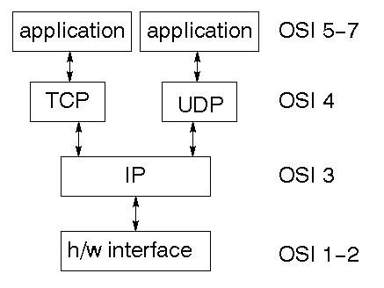
TCP is a connection-oriented protocol; UDP (User Datagram Protocol) is a connectionless protocol.

IP datagram’s
The IP layer provides a connectionless and unreliable delivery system. It considers each datagram independently of the others. Any association between datagram must be supplied by the higher layers. The IP layer supplies a checksum that includes its own header. The header includes the source and destination addresses. The IP layer handles routing through an Internet. It is also responsible for breaking up large datagram into smaller ones for transmission and reassembling them at the other end.

UDP
UDP is also connectionless and unreliable. What it adds to IP is a checksum for the contents of the datagram and port numbers. These are used to give a client/server model - see later.

TCP
TCP supplies logic to give a reliable connection-oriented protocol above IP. It provides a virtual circuit that two processes can use to communicate.

Internet addresses
In order to use a service, you must be able to find it. The Internet uses an address scheme for machines so that they can be located. The address is a 32 bit integer which gives the IP address. This encodes a network ID and more addressing. The network ID falls into various classes according to the size of the network address.

Network address
Class A uses 8 bits for the network address with 24 bits left over for other addressing. Class B uses 16 bit network addressing. Class C uses 24 bit network addressing and class D uses all 32.

Subnet address
Internally, the UNIX network is divided into sub networks. Building 11 is currently on one sub network and uses 10-bit addressing, allowing 1024 different hosts.

Host address
8 bits are finally used for host addresses within our subnet. This places a limit of 256 machines that can be on the subnet.

Total address
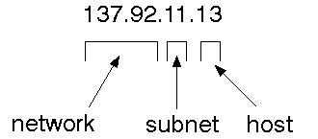
The 32 bit address is usually written as 4 integers separated by dots.

Port addresses
A service exists on a host, and is identified by its port. This is a 16 bit number. To send a message to a server, you send it to the port for that service of the host that it is running on. This is not location transparency! Certain of these ports are "well known".

Sockets
A socket is a data structure maintained by the system to handle network connections. A socket is created using the call socket. It returns an integer that is like a file descriptor. In fact, under Windows, this handle can be used with Read File and Write File functions.
#include <sys/types.h>
#include <sys/socket.h>
int socket(int family, int type, int protocol);
Here "family" will be AF_INET for IP communications, protocol will be zero, and type will depend on whether TCP or UDP is used. Two processes wishing to communicate over a network create a socket each. These are similar to two ends of a pipe - but the actual pipe does not yet exist.

JFree Chart
JFreeChart is a free 100% Java chart library that makes it easy for developers to display professional quality charts in their applications. JFreeChart's extensive feature set includes:
- a consistent and well-documented API, supporting a wide range of chart types;
- a flexible design that is easy to extend, and targets both server-side and client-side applications;
- support for many output types, including Swing components, image files (including PNG and JPEG), and vector graphics file formats (including PDF, EPS and SVG);
- JFreeChart is "open source" or, more specifically, free software. It is distributed under the terms of the GNU Lesser General Public Licence (LGPL), which permits use in proprietary applications.

1. Map Visualizations
Charts showing values that relate to geographical areas. Some examples include: (a) population density in each state of the United States, (b) income per capita for each country in Europe, (c) life expectancy in each country of the world. The tasks in this project include:
- sourcing freely redistributable vector outlines for the countries of the world, states/provinces in particular countries (USA in particular, but also other areas);
- creating an appropriate dataset interface (plus default implementation), a rendered, and integrating this with the existing XYPlot class in JFreeChart;
- Testing, documenting, testing some more, documenting some more.

2. Time Series Chart Interactivity
Implement a new (to JFreeChart) feature for interactive time series charts --- to display a separate control that shows a small version of ALL the time series data, with a sliding "view" rectangle that allows you to select the subset of the time series data to display in the main chart.

3. Dashboards
There is currently a lot of interest in dashboard displays. Create a flexible dashboard mechanism that supports a subset of JFreeChart chart types (dials, pies, thermometers, bars, and lines/time series) that can be delivered easily via both Java Web Start and an applet.

4. Property Editors
The property editor mechanism in JFreeChart only handles a small subset of the properties that can be set for charts. Extend (or reimplement) this mechanism to provide greater end-user control over the appearance of the charts.

System Design:
Design Overview

Design involves identification of classes, their relationships as well as their collaboration. In objectory ,classes were divided into Entity classes ,interface classes and the control classes. The Computer Aided Software Engineering tools that are available commercially do not provide any assistance in this transition. Even research CASE tools take advantage of meta modeling are helpful only after the construction of class diagram is completed. In the Fusion method ,it used some object-oriented approaches like Object Modeling Technique(OMT), Class_Responsibility_Collaborator(CRC) and Objectory,used the term Agents to represent some of the hardware and software systems .In Fusion method, there was no requirement phase ,where in a user will supply the initial requirement document. Any software project is worked out by both analyst and designer. The analyst creates the Use case diagram. The designer creates the Class diagram. But the designer can do this only after the analyst has created the Use case diagram. Once the design is over it is need to decide which software is suitable for the application

Sequence Diagram:
User
Server
BGP
Select Node
Select Node
Node Selected
Selection Finished
Process Intialized
Continue Process
Select File
File Accepted
Send Request
Request to File Transfer
Send Ack
Send Ack
Ack Received
Process Over

Data Flow Diagram

A data flow diagram (DFD) is graphic representation of the "flow" of data through business functions or processes. More generally, a data flow diagram is used for the visualization of data processing. It illustrates the processes, data stores, external entities, data flows in a business or other system and the relationships between them

Source 1
Source 2
Router

It chose the best path
BGP-Border Gateway Protocol
It updates the router Information
Source 3

IPDF-Inter domain packet Filter, It allow or discard the packet
Destination 2
Destination 1
Destination 3

Use case diagram:

]
Browse for a file to send
Choosing a destination to send

casting
Viewing the received data save the file
User

ER diagram:
Topology construction:

Topology construction
Node Information
System Name

PortNo
NodeName
Connection table
NodeName
Neighbour
Cost
Delay

Complete :

Route calc/BGP/IDPF
Calc/update
Node Information
System Name

PortNo
NodeName
Connection table
NodeName
Neighbour
Cost
Delay
Pda Table
path
cost
delay
Possible delay table
Destination
Path
Delay
Possible path
Destination
path
Cost
Delay

IDPF filtering:
Node Information
System Name

PortNo
NodeName
Connection table
NodeName
Neighbour
Cost
Delay
Possible path
Destination
path
Cost
Delay
Verify
Packet allow or discard
Received Packet header

SYSTEM TESTING

The purpose of testing is to discover errors. Testing is the process of trying to discover every conceivable fault or weakness in a work product. It provides a way to check the functionality of components, sub assemblies, assemblies and/or a finished product It is the process of exercising software with the intent of ensuring that the Software system meets its requirements and user expectations and does not fail in an unacceptable manner. There are various types of test. Each test type addresses a specific testing requirement.

TYPES OF TESTS

Unit testing
Unit testing involves the design of test cases that validate that the internal program logic is functioning properly, and that program input produce valid outputs. All decision branches and internal code flow should be validated. It is the testing of individual software units of the application .it is done after the completion of an individual unit before integration. This is a structural testing, that relies on knowledge of its construction and is invasive. Unit tests perform basic tests at component level and test a specific business process, application, and/or system configuration. Unit tests ensure that each unique path of a business process performs accurately to the documented specifications and contains clearly defined inputs and expected results.

Integration testing
Integration tests are designed to test integrated software components to determine if they actually run as one program. Testing is event driven and is more concerned with the basic outcome of screens or fields. Integration tests demonstrate that although the components were individually satisfaction, as shown by successfully unit testing, the combination of components is correct and consistent. Integration testing is specifically aimed at exposing the problems that arise from the combination of components.

Functional test

Functional tests provide a systematic demonstrations that functions tested are available as specified by the business and technical requirements, system documentation , and user manuals.
Functional testing is centered on the following items:
Valid Input : identified classes of valid input must be accepted.
Invalid Input : identified classes of invalid input must be rejected.
Functions : identified functions must be exercised.
Output : identified classes of application outputs must be exercised.
Systems/Procedures : interfacing systems or procedures must be invoked.

Organization and preparation of functional tests is focused on requirements, key functions, or special test cases. In addition, systematic coverage pertaining to identify Business process flows; data fields, predefined processes, and successive processes must be considered for testing. Before functional testing is complete, additional tests are identified and the effective value of current tests is determined.

System Test
System testing ensures that the entire integrated software system meets requirements. It tests a configuration to ensure known and predictable results. An example of system testing is the configuration oriented system integration test. System testing is based on process descriptions and flows, emphasizing pre-driven process links and integration points.

White Box Testing
White Box Testing is a testing in which in which the software tester has knowledge of the inner workings, structure and language of the software, or at least its purpose. It is purpose. It is used to test areas that cannot be reached from a black box level .

Black Box Testing
Black Box Testing is testing the software without any knowledge of the inner workings, structure or language of the module being tested . Black box tests, as most other kinds of tests, must be written from a definitive source document, such as specification or requirements document, such as specification or requirements document. It is a testing in which the software under test is treated, as a black box .you cannot “see” into it. The test provides inputs and responds to outputs without considering how the software works.

6.1 Unit Testing:

Unit testing is usually conducted as part of a combined code and unit test phase of the software lifecycle, although it is not uncommon for coding and unit testing to be conducted as two distinct phases.

Test strategy and approach
Field testing will be performed manually and functional tests will be written in detail.

Test objectives
- All field entries must work properly.
- Pages must be activated from the identified link.
- The entry screen, messages and responses must not be delayed.

Features to be tested
- Verify that the entries are of the correct format
- No duplicate entries should be allowed
- All links should take the user to the correct page.

6.2 Integration Testing

Software integration testing is the incremental integration testing of two or more integrated software components on a single platform to produce failures caused by interface defects.
The task of the integration test is to check that components or software applications, e.g. components in a software system or – one step up – software applications at the company level – interact without error.

Test Results: All the test cases mentioned above passed successfully. No defects encountered.

6.3 Acceptance Testing

User Acceptance Testing is a critical phase of any project and requires significant participation by the end user. It also ensures that the system meets the functional requirements.

Test Results: All the test cases mentioned above passed successfully. No defects encountered.

IMPLEMENTATION

Implementation is the stage of the project when the theoretical design is turned out into a working system. Thus it can be considered to be the most critical stage in achieving a successful new system and in giving the user, confidence that the new system will work and be effective.

The implementation stage involves careful planning, investigation of the existing system and it’s constraints on implementation, designing of methods to achieve changeover and evaluation of changeover methods.

Implementation is the process of converting a new system design into operation. It is the phase that focuses on user training, site preparation and file conversion for installing a candidate system. The important factor that should be considered here is that the conversion should not disrupt the functioning of the organization.

The project IP spo0ofing is implemented for protecting network from DDOS attacks in a network. That Addresses availability and scalability with respect to management of redundant data.

We propose IDPF filtering and BGP protocols for the above implementation that solve the problem in a scalable and decentralized fashion that does not compromise the availability requirements of the application.

The implementation can be preceded through the java Socket and ServerSocket in peer to peer communication. For the duplicate eliminations java will be more suitable for platform independence and networking concepts. For maintaining the paths we are using Microsoft SQL server as database back end.

Modules:
- Nodes Constructions
- Route Calculation
- Border Gateway Protocol
- Inter Domain Packet Filtering

Node Constructions:
In this module we design a network topology to register the nodes. In the network, numerous nodes are interconnected and exchange data or services directly with each other.

Route Calculation:
In this module we calculate the route between the source node to destination node. And find out the shortest path .This details is append to the Packet header. It used for packet transmission. Packet forward to BGP.

Border Gateway Protocol:
In this module we find out the Packet header details and extract the source IP from packet header. Calculate the route details and find out the shortest path. This detail is appended to packet header.

Inter Domain Packet Filtering:

In this module we extract the route details from packet header and compare those two routes. Each node has the different shortest path for communicate the destination. So our route based approach give the valuable solution for IP Spoofing. If routes not varied packet allowed or packet discards.

CONCLUSION:
We have proposed and studied an IDPF architecture as an effective countermeasure to the IP spoofing- based DDoS attacks. IDPFs rely on BGP update messages exchanged on the Internet to infer the validity of source address of a packet forwarded by a neighbor.Weshowed that IDPFs can easily be deployed on the current BGP-based Internet routing architecture. We studied the conditions under which the IDPF framework can correctly work without discarding any valid packets. Our simulation results showed that, even with partial deployment on the Internet, IDPFs can significantly limit the spoofing capability of attackers. Moreover, they also help pinpoint the true origin of an attack packet to be within a small number of candidate networks, thus simplifying the reactive IP traceback process.

Future enhancement:
Most DDoS attacks require a persistent train of packets to be directed at a victim, not discarding spoofed packets for this short period of time should be acceptable. We plan to further investigate the related issues in the future. In short, IDPFs can handle the routing dynamics caused by network failures, which may cause long route convergence times. IDPFs may, however, drop packets in the network recovery events. We argue that this is not a big problem, since 1) the network recovery events typically have a short convergence time and 2) such events can also cause service disruptions in the original BGP without IDPF.

Bibliography:
- CANN SSAC Advisory SAC008 DNS Distributed Denial of Service (DDoS) Attacks, Mar. 2006.
- C. Labovitz, D. McPherson, and F. Jahanian, “Infrastructure Attack Detection and Mitigation,” Tutorial, Proc. ACM SIGCOMM, Aug. 2005.
- R. Beverly and S. Bauer, “The Spoofer Project: Inferring the Extent of Internet Source Address Filtering on the Internet,” Proc. First Usenix Steps to Reducing Unwanted Traffic on the Internet Workshop, July 2005.
- S. Kandula, D. Katabi, M. Jacob, and A. Berger, “Botz-4-Sale: Surviving Organized DDoS Attacks that Mimic Flash Crowds,” Proc. Second Symp. Networked Systems Design and Implementation, 2005.
- D. Moore, C. Shannon, D. Brown, G. Voelker, and S. Savage, “Inferring Internet Denial-of-Service Activity,” ACM Trans. Computer Systems, vol. 24, no. 2, May 2006.
- R. Pang, V. Yegneswaran, P. Barford, V. Paxson, and L. Peterson, “Characteristics of Internet Background Radiation,” Proc. ACM Internet Measurement Conf., Oct. 2004.
- S. Savage, D. Wetherall, A. Karlin, and T. Anderson, “Practical Network Support for IP Traceback,” Proc. ACM SIGCOMM Computer Comm. Rev., vol. 30, no. 4, Oct. 2000.
- P. Watson, “Slipping in the Window: TCP Reset Attacks,” Proc. Fifth CanSecWest/core04 Conf., 2004.
- J. Stewart, “DNS Cache Poisoning—The Next Generation,” technical report, LURHQ, Jan. 2003.
- V. Paxson, “An Analysis of Using Reflectors for Distributed Denial-of-Service Attacks,” ACM Computer Comm. Rev., vol. 31, no. 3, July 2001.
- ”CERT Advisory ca-1996-21 TCP SYN Flooding and IP Spoofing Attacks,”CERT, http://www.cert.org/advisories/CA-1996- 21.html, 1996.
- K. Park and H. Lee, “On the Effectiveness of Route-Based Packet Filtering for Distributed DoS Attack Prevention in Power-Law Internets,” Proc. ACM SIGCOMM, Aug. 2001.
- Y. Rekhter and T. Li, “A Border Gateway Protocol 4 (BGP-4),” RFC 1771, Mar. 1995.

Connection table:
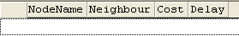

NodeInformation table:
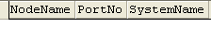

Pda table:
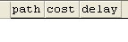

Possibledelay table:
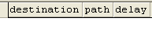
Possiblepath table:
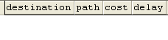

Screens:
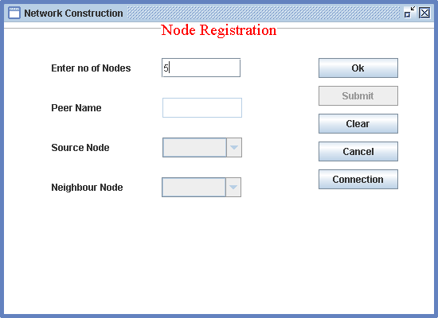
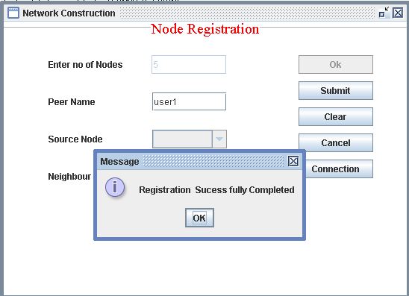
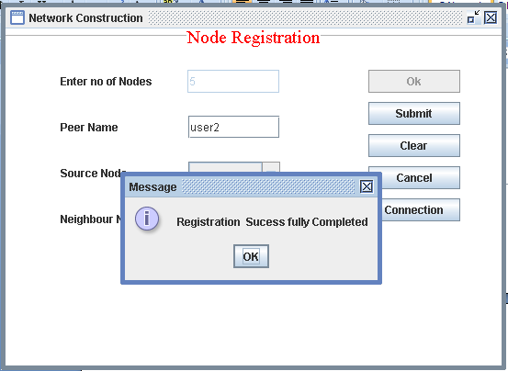

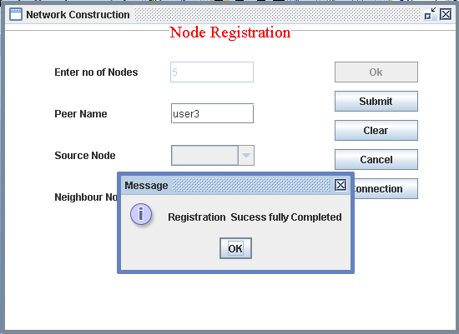
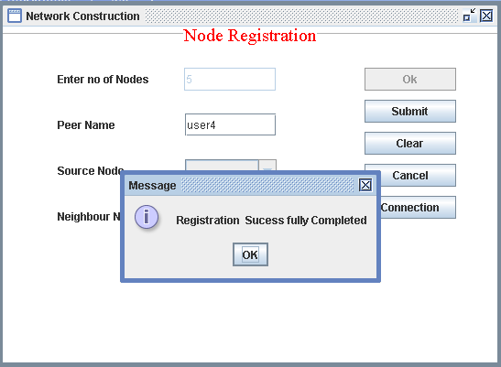
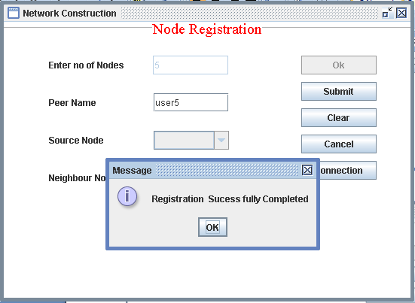

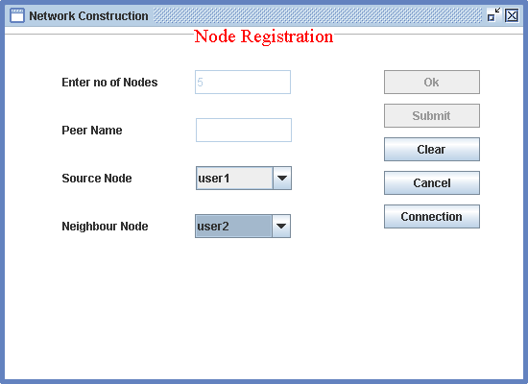
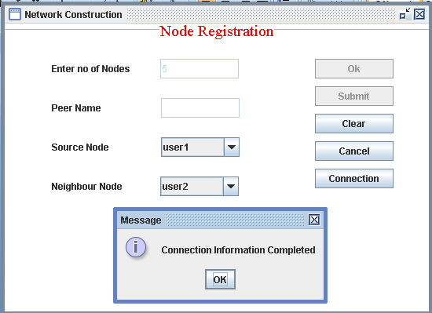

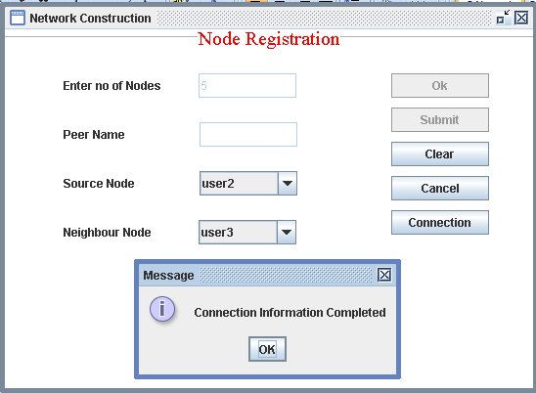
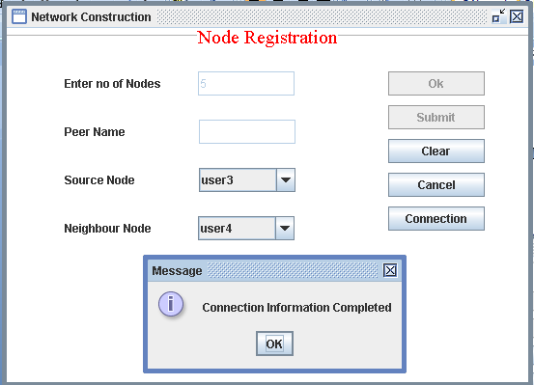

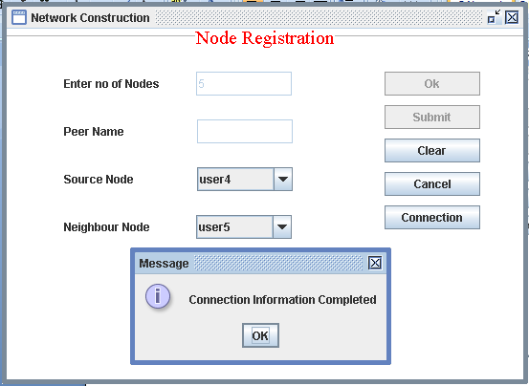
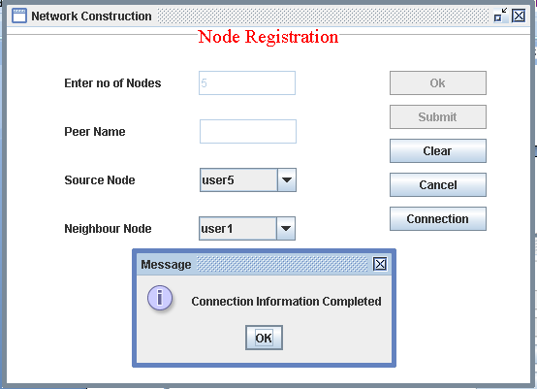

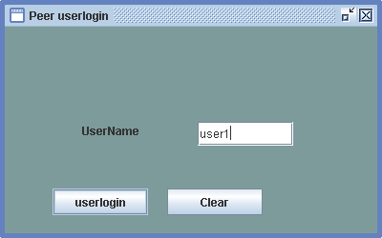
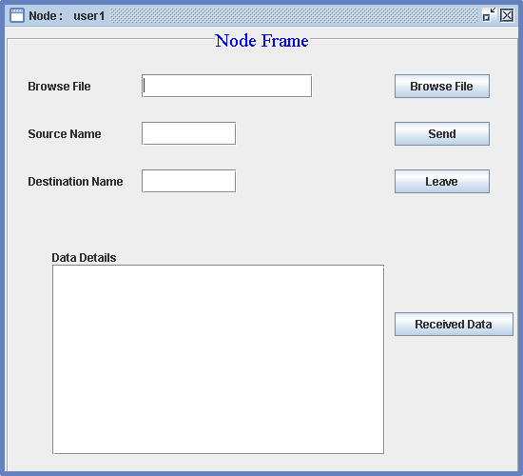
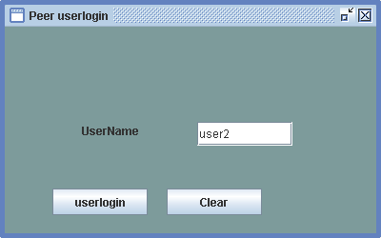
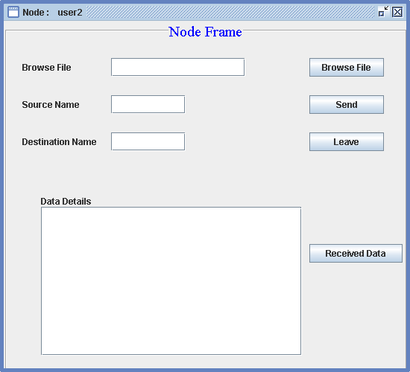
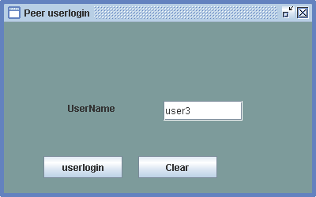
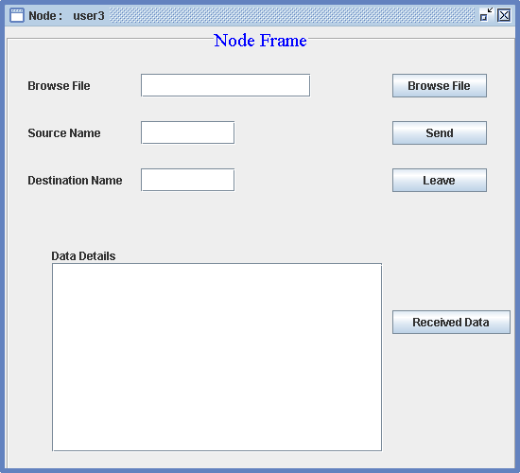

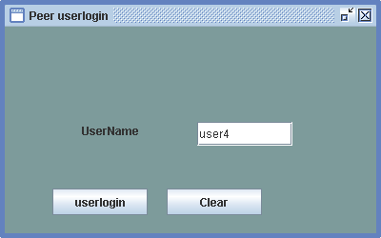
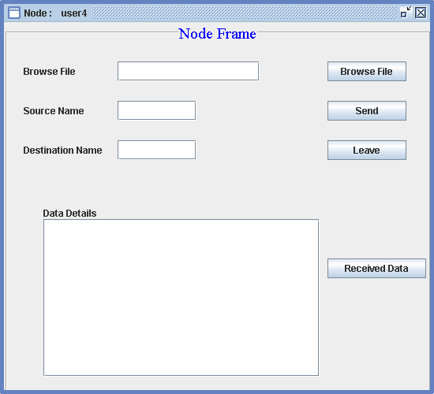
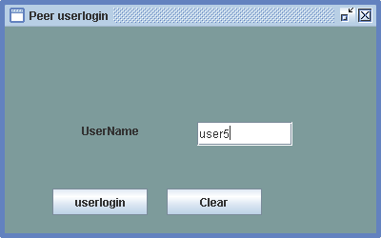
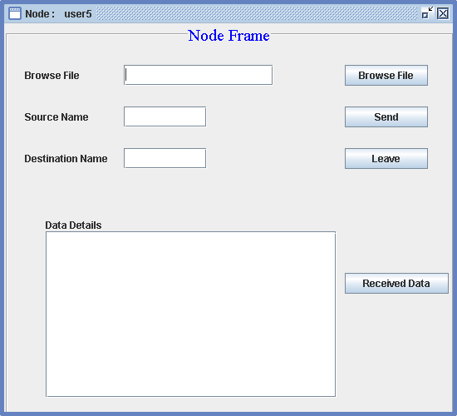
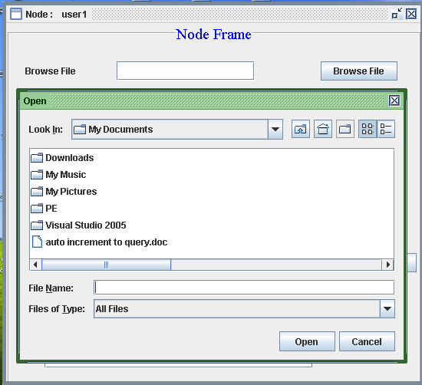
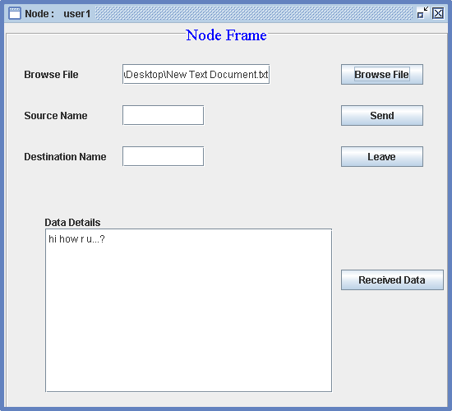
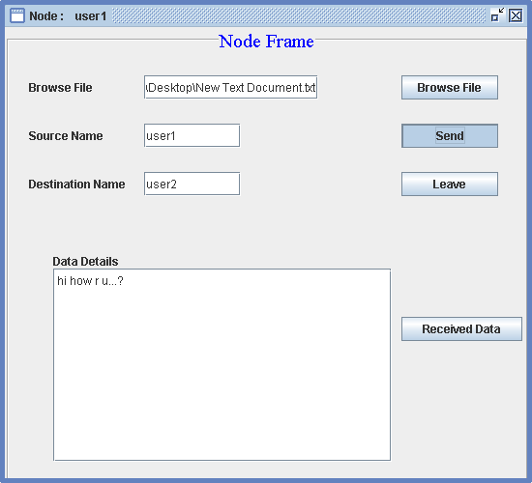
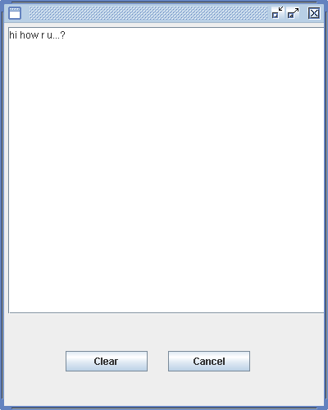
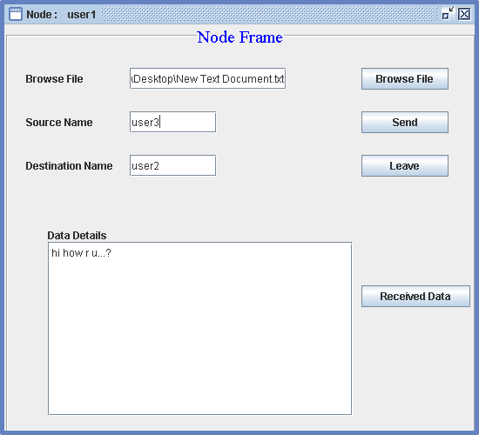
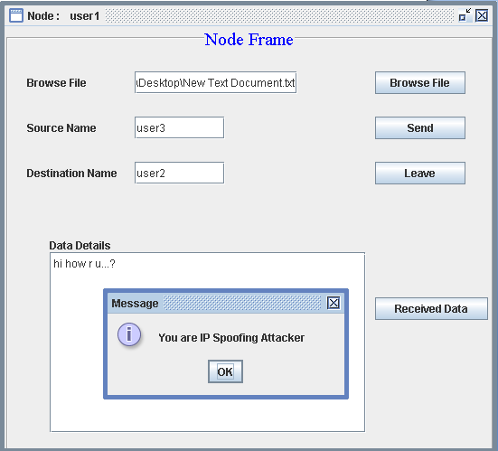

Sample coding:
Networkserver.java
import java.awt.*;
import java.awt.event.*;
import javax.swing.*;
import java.sql.*;
import java.io.*;
import java.net.*;
import java.util.*;

public class networkserver extends JFrame
{

private JPanel contentPane;

private dataconnect z;
ResultSet rs;
Connection cs;
Statement st;
Vector v,v1,v2;
static ServerSocket sersoc;
static Socket soc,soc1;
ObjectInputStream dis,dis1;
ObjectOutputStream dos,dos1;
InputStream is;
OutputStream os;

String n="",ip="";
String a[]=new String[100];
static networkserver m;
int portno=5000,port;
link find;
int number;
String bgp="127.0.0.1";
public networkserver()throws Exception
{
super();
z = new dataconnect();
st=z.connect();
st.execute("delete nodeinformation");
st.execute("delete connection");
st.execute("delete possiblepath");
st.execute("delete pda");
new connectnodes();

}

public void listen()throws Exception
{

int port=0;
dis=new ObjectInputStream(soc.getInputStream());
String request=(String)dis.readObject();
System.out.println("recived:"+request);
if(request.equals("path"))
{

String nodes=(String)dis.readObject();
String array[]=nodes.split("&");
System.out.println("nodes:"+nodes);
find= new link(array[0],array[1]);
rs=st.executeQuery("Select PortNo from nodeinformation where Status='ON' ");
if(rs.next())
{
rs=st.executeQuery("Select path from possiblepath where destination='"+array[1]+"' ");
v1=new Vector();
while(rs.next())
{

v1.add(rs.getString(1));
}
System.out.println(" v1"+v1);
}
System.out.println("send v1");

System.out.println(" v1"+v1);
/*dos=new ObjectOutputStream(soc.getOutputStream());

dos.writeObject(v1);*/

System.out.println(" v1 size"+v1.size());

String path= find.bestcost(4,array[1]);

System.out.println("path:"+path);

//-----------------------------------
st.execute("delete possiblepath");
st.execute("delete pda");

find= new link(array[2],array[1]);
rs=st.executeQuery("Select PortNo from nodeinformation where Status='ON' ");
if(rs.next())
{
rs=st.executeQuery("Select path from possiblepath where destination='"+array[1]+"' ");
v2=new Vector();
while(rs.next())
{

v2.add(rs.getString(1));
}
System.out.println(" v1"+v2);
}
System.out.println("send v2");

System.out.println(" v2"+v2);
/*dos=new ObjectOutputStream(soc.getOutputStream());

dos.writeObject(v1);*/

System.out.println(" v2 size"+v2.size());

String path1= find.bestcost(4,array[1]);

System.out.println("path1:"+path1);

System.out.println("send v1");
soc1=new Socket("127.0.0.1",5000);
dos1=new ObjectOutputStream(soc1.getOutputStream());
String ph=array[2]+"&"+path1;
dos1.writeObject(ph);
dos1=new ObjectOutputStream(soc1.getOutputStream());
String ph1=array[0]+"&"+path;
dos1.writeObject(ph1);
dis1=new ObjectInputStream(soc1.getInputStream());
String result=(String)dis1.readObject();
System.out.println("result:"+result);
if(result.equals("yes"))
{

dos=new ObjectOutputStream(soc.getOutputStream());

dos.writeObject(path);
}
else
{
dos=new ObjectOutputStream(soc.getOutputStream());

dos.writeObject("attacker");
}

}
else if(request.equals("portno"))
{
String nodes=(String)dis.readObject();

System.out.println("nodes:"+nodes);

rs=st.executeQuery("Select PortNo from nodeinformation where NodeName='"+nodes+"' ");

if(rs.next())
{
//System.out.println("p:"+rs.getString(1));
port=Integer.parseInt(rs.getString(1));
}
rs=st.executeQuery("Select SystemName from nodeinformation where NodeName='"+nodes+"' ");

if(rs.next())
{
ip=rs.getString(1);
}
dos=new ObjectOutputStream(soc.getOutputStream());

String p=String.valueOf(port);
System.out.println("p:"+p);
System.out.println("ip:"+ip);
dos.writeObject(p);
dos.writeObject(ip);
System.out.println("send 1");

}
else if(request.equals("port"))
{

System.out.println("1");
String nodes=(String)dis.readObject();

System.out.println("nodes:"+nodes);

rs=st.executeQuery("Select PortNo from nodeinformation where NodeName='"+nodes+"' ");

if(rs.next())
{
//System.out.println("p:"+rs.getString(1));
port=Integer.parseInt(rs.getString(1));
}
rs=st.executeQuery("Select SystemName from nodeinformation where NodeName='"+nodes+"' ");

if(rs.next())
{
ip=rs.getString(1);
}
dos=new ObjectOutputStream(soc.getOutputStream());

String p=String.valueOf(port);
System.out.println("p:"+p);
System.out.println("ip:"+ip);
dos.writeObject(p);
dos.writeObject(ip);
System.out.println("send 1");

}
else if(request.equals("neighbours"))
{
Vector nv=new Vector();
dis=new ObjectInputStream(soc.getInputStream());
String neigh=(String)dis.readObject();
rs=st.executeQuery("Select Neighbour from Connection where NodeName='"+neigh+"'");
while(rs.next())
{
nv.addElement(rs.getString(1));
}
dos=new ObjectOutputStream(soc.getOutputStream());

dos.writeObject(nv);
}
else if(request.equals("path1"))
{
Vector nv1=new Vector();
// dis=new ObjectInputStream(soc.getInputStream());
String neigh1=(String)dis.readObject();
rs=st.executeQuery("Select Neighbour from Connection where NodeName='"+neigh1+"'");
while(rs.next())
{
nv1.addElement(rs.getString(1));
}
dos=new ObjectOutputStream(soc.getOutputStream());

dos.writeObject(nv1);

}
else if (request.equals("exit"))
{
dis=new ObjectInputStream(soc.getInputStream());
String nn=(String)dis.readObject();
System.out.println("z:"+nn);

st.executeUpdate( "update nodeinformation set PortNo='0' where NodeName='"+nn+"'" );

}

else if(request.equals("user"))
{

dis=new ObjectInputStream(soc.getInputStream());
System.out.println("1");
String details=(String)dis.readObject();
System.out.println("2");
String z[]=details.split("&");
System.out.println("3");
rs=st.executeQuery("Select PortNo from nodeinformation where NodeName='"+z[0]+"' ");

if(rs.next())
{
//System.out.println("p:"+rs.getString(1));
number=Integer.parseInt(rs.getString(1));
}
if(number==0)
{
st.executeUpdate( "update nodeinformation set PortNo='"+z[2]+"' where NodeName='"+z[0]+"'" );
System.out.println("4");
st.executeUpdate( "update nodeinformation set SystemName='"+z[1]+"' where NodeName='"+z[0]+"'" );
System.out.println("5");
}
else
{
System.out.println(number);
}

//dos=new ObjectOutputStream(soc.getOutputStream());
// port=port+1;

System.out.println("8");
}
else
{
dos=new ObjectOutputStream(soc.getOutputStream());
portno=portno+1;

String p=String.valueOf(portno);
System.out.println("p:"+p);

dos.writeObject(p);

System.out.println("send");
}
}

//============================= Testing ================================//
//= =//
//= The following main method is just for testing this class you built.=//
//= After testing,you may simply delete it. =//
//======================================================================//
public static void main(String[] args)
{
JFrame.setDefaultLookAndFeelDecorated(true);
JDialog.setDefaultLookAndFeelDecorated(true);
try
{

sersoc=new ServerSocket(1500);
m=new networkserver();
while(true)
{
soc=sersoc.accept();
m.listen();
}
//UIManager.setLookAndFeel("javax.swing.plaf.metal.MetalLookAndFeel");
}
catch (Exception ex)
{
System.out.println("Failed loading L&F: ");
System.out.println(ex);
}

}
//= End of Testing =

}

